**The Park Friendly Location in Toronto Neighbourhoods**

Qisheng Yin

July 31, 2020

1. **Introduction**

**A.1. Description and Discussion of the Background**

John, a new graduate from University of Toronto, just got a job offer in Toronto. He is thrilled to start his Career in this beautiful city. However, right now his first priority becomes finding a new apartment in Toronto.

John loves nature. His enjoy bird watching, biking, jogging and running, basically everything people like to do in the park. Therefore, his only requirement for the apartment is that it must be adjacent to lots of parks in Toronto. Not only it fit John’s personal lifestyle, now that a growing number of people start to realize the importance of preserving the environment, he believes it will also be a good investment as well.

Therefore, the goal becomes how do we use the data from Foursquare to help John find a place that can access to most of the parks in Toronto.

A.2 Data Description

Foursquare API was used to get the location information of all the parks in Toronto. Also, the GeoPy function in Python was utilized to convert an address into latitude and longitude values.

1. **Methodology**

First, by searching venue “parks” and define a radius 0f 20,000 km using Foursquare API, I was able to get a list of all the parks around Toronto and its geographical information.

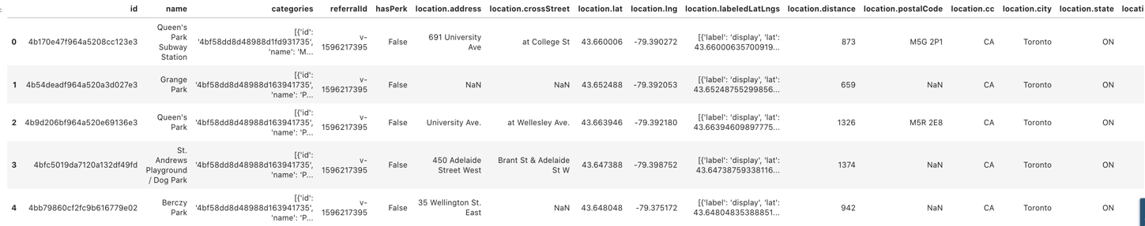

I filter the location in Toronto because that is the place I only care for. Furthermore, I dropped all the other columns and only saved the latitude and longitude data. Here is the processed data generated for the clustering analysis:

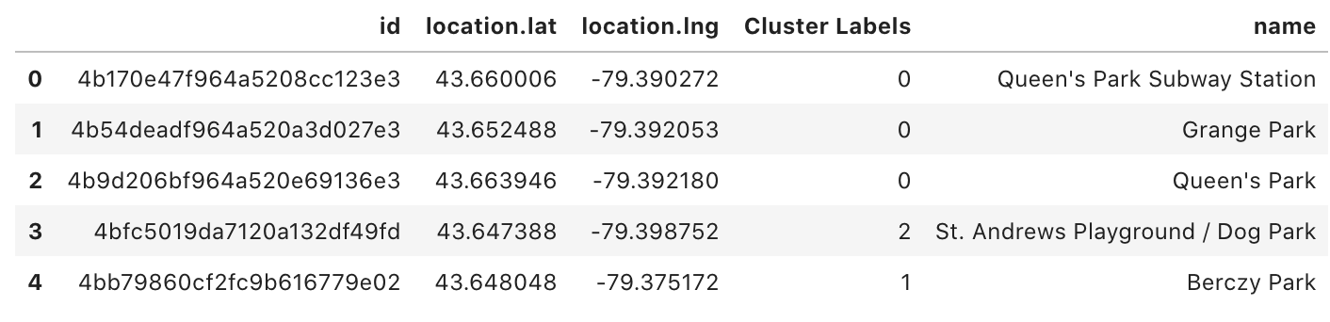

Folium Library will be used to visualize the geographic details of the parks in Toronto. Here is the map showing all the parks I will analyse:

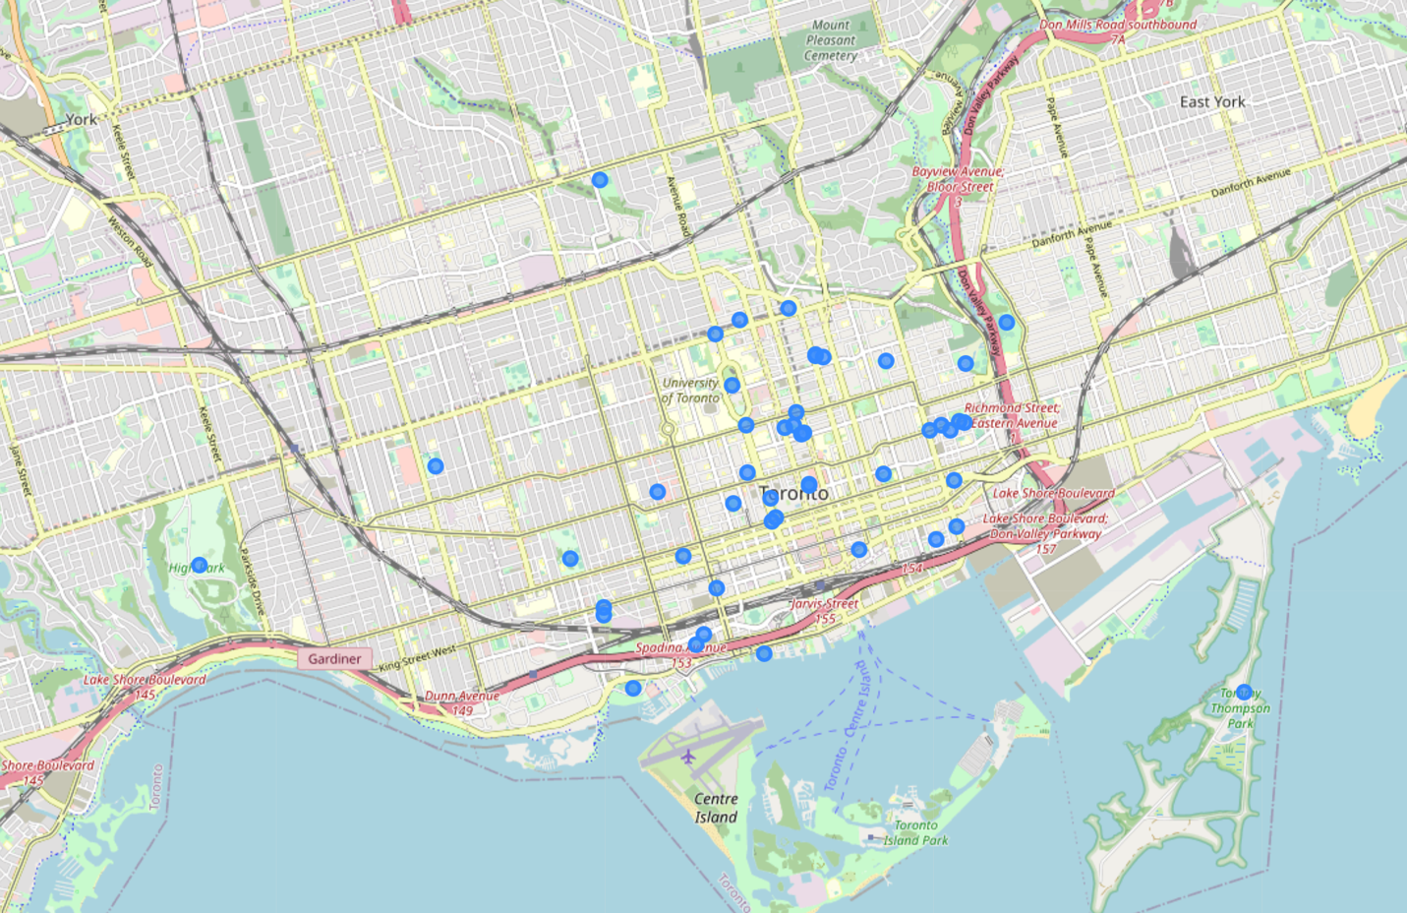

Finally, K-means clustering will be used to cluster the parks based on their latitude and longitude.

1. Results

Here is a snapshot of the result of K-means clustering for the parks in Toronto. Each Park is assigned to a number under cluster labels.

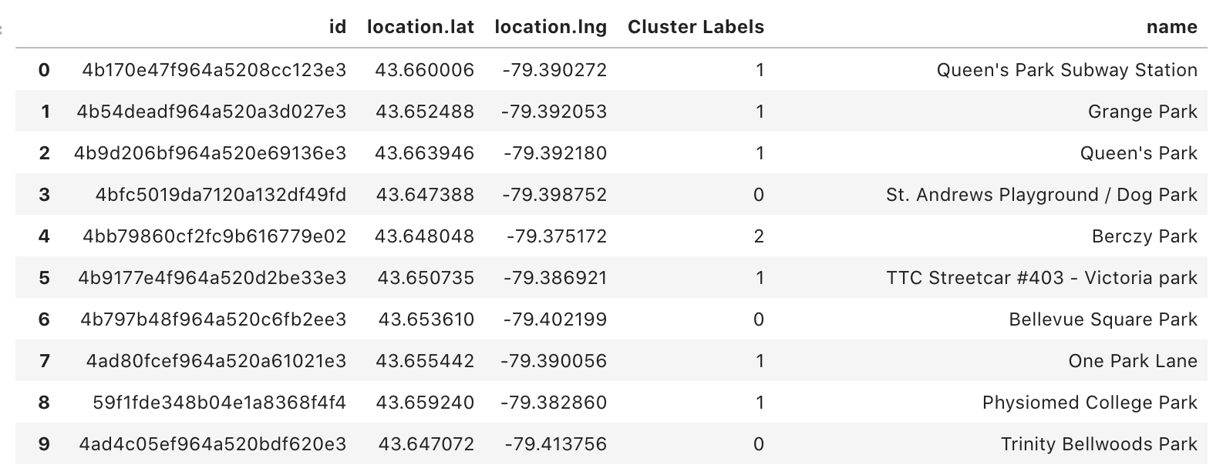

And we visualize the clustering using Folium and assigned different cluster using different colors:

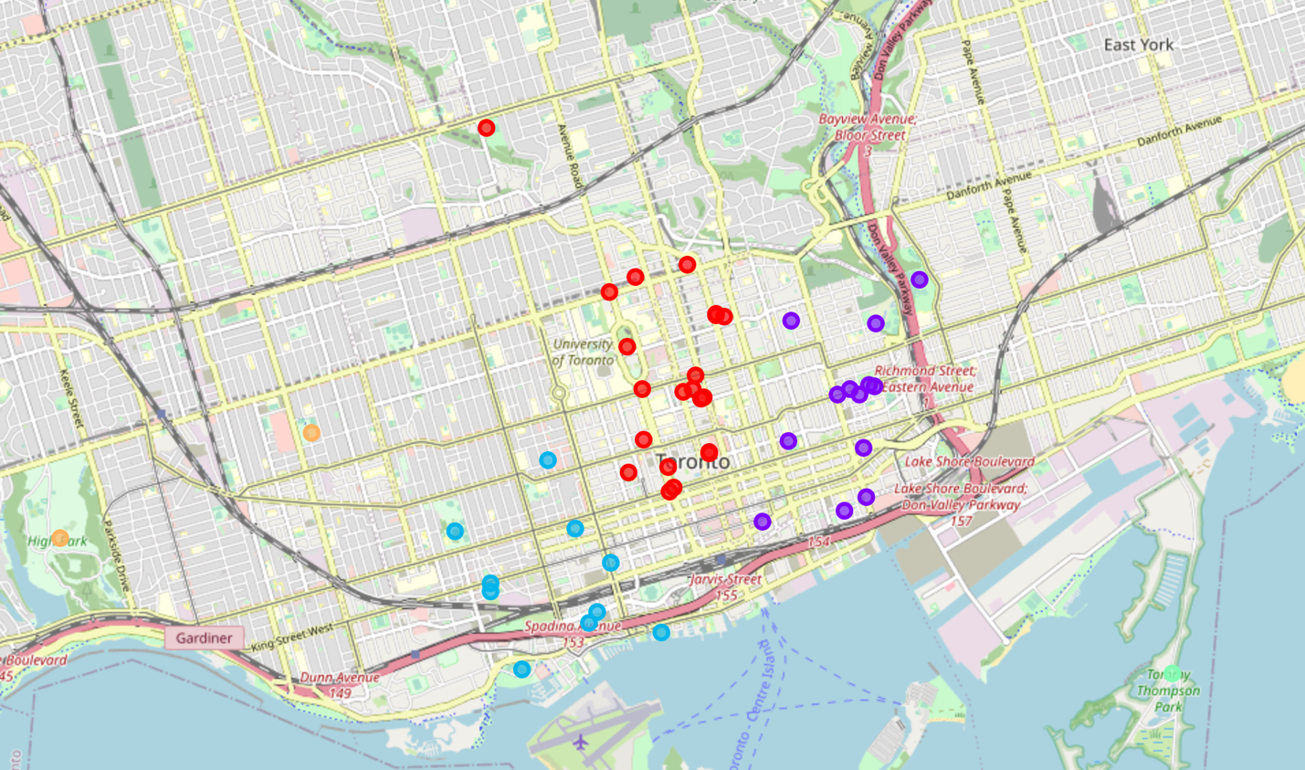

Results shows cluster 1(in red) has 21 parks in its group and it has the highest number of the parks among each cluster. Here is the complete list:

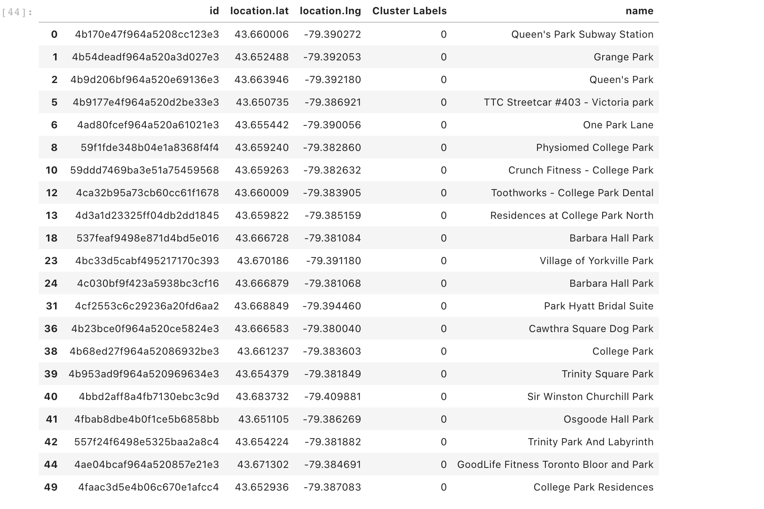

From there, we can generate the center point of cluster 1 and here is the location on a map:

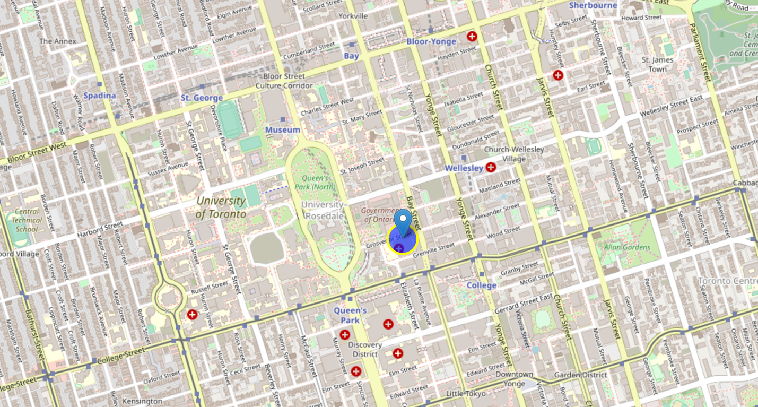

That place is near the 80 Grosvenor St, Toronto, ON M7A 1E9. The closest condo around the area is called Burano Condos.

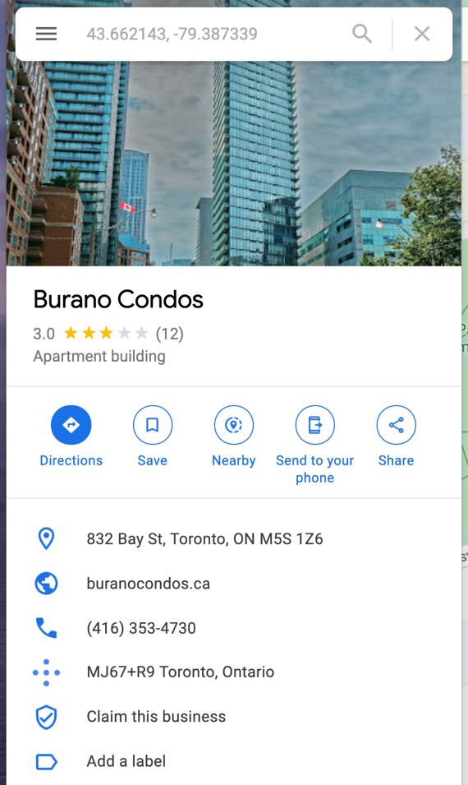

1. Conclusion

John, who loves visiting parks is looking for a place where he can access most of the parks in Toronto

By utilizing the location data from Foursquare and K-mean analysis, we can tell the most ideal park friendly apartment is around the neighbourhood of 80 Grosvenor St, Toronto. For example, Burano Condos.